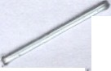
• •

•

1..,,•.<cmc• c.zJ• ,...
??ri. t No. o,
m:rn·eirc•:aIE:ar.. .

1 u-lie rl Str£t,
P.·o.Eo 3EM-8
C.ar $-'S Sa:zar1 - Tar lri;a

•
.---
'  I 1atre: |  |  | P?.F OKIA YA MT CLARA-KANYERERE
• .-,,,.._ r ""' •  I,,;• .:.:..  / |  |  | I • • 'NV.C_ ,::,:>_.;: ,,:::E - Dar es Salaam  .
Bran,-;h: |  |  | Bucando
- |  |  | 013
9""anc.h c .,.
( I""" . -.1\.o,
Qp.:.>n C':" | : |  | 13-Scp-202,

... ••

•
P.. un·t Nunf sr: | 01324317822701
A. un!Frod1..:ct | Ccmmunit/ Current Acccunt (TZS)
,,. cccunt C•.:;·1·ur.c:-,1: | Tc:r.zsnian Shiiling {iSri)
ClD A/C Numr; I | BR.()1321720287701
.  'Frcrn Dts | 01-Jon-'2026  ---
1o D·-\.,....,.·  . | 3 -Mar-2026

••
- ----- • •

.,

02/C 1/'2.02S
I

•
0 1011. 1J26 13:;:a

E) t-A.B TFR-[Cash depos:t through Zal<'Nan
-

Investment Trading Account,
I·
1,117,BCO.OO 31,€ 8,5 12.21)
-'--­
•

05/01/2026 05/0 '1/:'..026 10:23

I
003"*"-.1r0691101, ref: A81767597562057, KIB.U. ty ALFREDA KAB1\-!<AMA] - 817675975§3057-4
Ext-,il.B_TFR-[Cash deposit through Zakv1an
1n,1estmenc Tradina Acccur:t,
0.00 763,0-00.CO ,.,.:,,,".-,,.:....i:,"'·9',,.. 1')...3\')
•

I
•

L6/Q1,.2
,-...L..... o... 1 ru.'>-=J10..1. /.2r..;rL
'_? 1·."..": ""
1

C:3**" 069 101, r f : AS 1767€37774S59,
a.co
"" 4"' - 8"' "' ,-., .,I

1 C
l r<ISP\ by ALF.={EO. K..\Bfl.KA 11: ,] -
::-1
6,300.CO
• • •
• • ' l- , ,11.....,;.._
_ _ _ .._"",1'_ I

•
07101/2026 07/01/2025 11:23
.L\81767637774959-4
.L\ccou nt Statement Fee (TZS) - 7 SOO 00 . a· 00 . '<2 40 ,., 1?

1767-1745184870-864780
Vall!e Added Tax--rzs On Account
-
-+- -- ---- 1 • -- -
• --+-
,_,- 1
G ,_; , _ ..:iu
I

07/01/2C26 07 01/205 11:28'
Statement Fae (TZS) - • - • 1,350.00 ·0.00 32,-1-06,£62. 1:· ' -

I
-. ,._ 1'2( ') '

1767774518639086d783 •

106 - Cheue Cash Withdra\val 3'(
• •
•

....J\U R:::1 lTl SY!...VESTER

0I v I .. ..... 07/01/202€ 11:58
21 LAURENTI SYLVESTER fV1A.SUI - . f lA_$Ul

1,162,0C0.00
O.CC
•

1-- 1-- --''-- --'1-7-67776037688- 0873367
-- --; ·- --1-- -,;-- -- · -+..-.......... • -- ---

Automatic Loan Rc;r,ayment by Transfar - ·
• . •

07/01/202'3 07/01/2026 20:29

1

17S78C6S612500132768
IExt-·EXT_TFR-[M2iipo ya ZAK.I\ tv1WA40227.
3,727,886.3"7 . • 0.00 •
- .
•

27,517,075.9:3

I

10/01/21)26
10/01i2026 11:25
fTransacticn ref ID DAA3M7JT8lF] -

IDA..3M7JT81F-2
'?.ecaived 5GOOOO from Parckia Ya tvlt •
·ar2Kanyerere Transaction Id: 003-

0.00
c. 6 0 C".1 ·--. .
"J \_., t ·-\:)
••

• • •

10/01/2026 10/01/2026 17:57
•
19ba8871a40fdaeb - OG3-
0.00 500,000,00
•• .

. • •. • .

1--- -+- --' -+- -=.- -+1-9· ba8671a40fda_e:.b_ -2- --. ·-t- -- -- -t-·- - -r- -
. ,_f.-'--..

--1

1J1011 026 13/01/2026 10:07
f xt-AB_TrR-[Cash deposit through Zakvvan Investmen t Trading Account, 003"**"C691101, re[: A817682S7eC0629,

A:-<l BA by RAULENT MA.SUU] -

AB1768287300629-4
1Ext-EXT_TFR-[rv1alipc ya ZAKA
..

0.00
7·' • •

.,.!...8,57

..;.... ,0..I.,.- .Q...,-1
1
•

17/C1/2026 . 17/01/2tJ25 3:04
l'vlWA..:102217. Transaction ref ID .
0.00 4,600.00 28, 57',7,L,.. I .,;-),.c.,,3

>-- ---!i-- _.1-- ---1DArl31lC7W1\/-0-''---DAH3 tv1C7\/V1V0--2
--; --;- -- 1- .-· · -..;-'.-- -- ----1

19/C 1/2C26 19/01/2C26 11:12

21/01/2026 1 1/01/2026 20:03

26/0·l /2026 2S/Oi/2026 12:50

•
Ext-AB_TrR-[Cash deposit through Zakwan
·Investment Trading Account,
C03"**."0691 101, ref: AB1768810084953, AKlBA bv RAULENTI - AB17E8810084953-4 R/E 00.1O/O·l/2026 REF.DAl\3M7J 81F -
01 3M7 JT81F .
Ext-AB_TFR-[Cash depcsit throt.gh Zakwan
Investment Tra<jing Account,
003"***0691 101, ref:ABi7694207579 10,

AKIBA by ALFR,ED 1-<ABAKAM.A: - •

0.00

9,600.00

•

0.00
.·
502,050.JO

- o.oo I
•-

29,079,32·5.93

29,069,7'25.93

29,642, 125.93

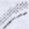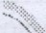P-s 1o:4

..

t
-
..:.

• •
•

AB1769420757910-4
I
•
28/0 1/2026 23/01/2026 09:01 •. fvlAENDELEO YA PAROKIA BY JUMUIYA JUtv1UIYA YA MT 0.00 250,000.00 29,892,125 .93 A MT lf\JYASl - 17695795554030561135 INYASI ,
••
106 - Cheque Cash VVithdrawal BY _ALJRENTI SYLVESTER

28/01/2026 28/01/20'26 12:01 22 LAURENTI SYLVESTER MASUI -
17695904614840615965
MASUI
1,370,0CO.OO 0.00 28,522,125.93

- Ext-EXT_TFR-[rvlalipo ya ZAK,L\ MWA402G. •
31/01/2026 31/01/2026 17:02 rrransaction ref ID DAV9fv1rv11TTVX] - 0.00 99,600.00 28,621,725.93
OAV9tv1MITTVX-2
Ext-EXT_TFR-[tvlalipo ya ZAK,!\
31/01/2026 31/01/2026 20:28 MvVA402217. Transactjon ref ID 0.00 4,600.CO 28,626,325.93 DAV5lvl MPRRT3l- DAV5MMPRRT3-2
/ Ext-AB_TFR-[Cash deposit through Zakwan
-V
Investment Trading Account,
0210212026 02/02/2026 12:18 003"*...*0691101, ref: AS 1770023595022, 0.00 1,314,950.00 . 29,941,275.93 AKIBA by ALFREDA KABAKAMA] - .
AB1770023595022-4
106 - Cheque Cash Withdrawal BY AURENTI SYLVESTER

03/02/2026 03/02/2026 13:55 23 LAURENTI SYLVESTER MASUI -
rv1ASU I
562,500.00 0.00 2S,378,775.93

17701160901320296497 .

-·- Ext-AB_TFR-(Cash deposit through ZakW :1n
Investment Trading Acccunt,
- - . ..

09/02/2026 09/02/2026 14:46 D03****0691101, ref:AB1770637334083, 0.00 691,500.00 30,070,275.93 AKIBA by ALFREDA KABA'<AMA] - •
AB1770637334083 -4
09i02/2C26 09/02/2026 21:12 Automatic Loan Repayment by Transfer - 3,727,886.37 0.00 26,342,389.56 17706607400430563440
IExt-AB_TFR-[Cash deosit cnrougn Za!<'han
17/C2/2026 16/02/2026 20:26 Investment Trading Account, 0.00 830,000.00 27,172,389.56
003**.l-*0691101, ref: AB1771265 0415,
.
•
A.KIBA by RAULENTl - A81771262510415
Ext-AS_TFR-[Cash deposit through Zakwc:n
2010212026. 20/02/2026 09:21 Investment Trading Account, 0.00 202,85C .OO 27,375,239.56
03****0691101, ref: A.B·l 771563203730,
.KIBA bv RAULE Tl - AB17715c820373C I
20/02/2026 2010212026 16:07 j101 - Cash Deposit-3.A.DAK.A - EVJl.RIST PATRICE 0.00 12,500,000.00 39,875,239.56

21/02/2026 21102/2026 10:16
17715927028840489981
. 101 - Cash Deposit-SADAKA - 1771658124677001 8442
C ARAHA ·ll
MAGOHE 0.00 4,900,000.00 4.dr,775,23.9. .56

. Received 448800 from Parokia Ya fvlt
. ClaraKanyerere Transaction Id: 504-

21./02/2026 21/02/2026 15:52
.
APCTZ198493513765632 - 504-
-:-. 0.00 448,800.00 45,224,039.56
•

APCTZ198493513765632-2 • .
Ext-AS_TFR-[Cash deposit through Zakwan
' Investment Trading .A.ccount,
•
•
23/02/2026 22/02/2026 11:51 003****0691101, ref: AB1771750043324, 0.00 EOO,CC0.00 45,724,039.56 MAENDELEO YA PAROKIA by JUMUHIYA
. . MT THOIVIAS WA WAKVVINO] - .
.
A81771750043324-4
106 - Cheque Cash Withdrawal SY 1'v1K.A.1\llA I

2:J 02/2023 23/02/20:26 12:33 24 MBOGOLA MKArvlA -
177183889297903065 88
•MKAMA l'v1BOGOLA
MKAtv1A
.. o,ooo,cao.oo 0.00 5,724,039.56

106.- Cheque Cash vVithdravJal BY _ALJRE NTI SYLVESTch

23/02/2026 2310212026 12:41 25 LAURENTI SYLVESTER i\tlASUI -
• 17718396172530309398
- . • Ext-A8_TFR-(Cash deposit through Zakwan
.
MASUI
500,000.00 0.00 5,224,C39.56

Investment Trading Account,
24/02/2026 24/02/2026 13:26 003****0691101, ref: A81771928516239, 0.00
SADAKA YA MSALABA by l\1ARRY YLYMO] AB 1771928516239-4
IExt-AB_TFR-[Cash deposit through Zakwan Investment Trading Account,
003****0691101, ref: AB1771934176271, ,..

. 157,000.00 5,381,039.56
.

2.4/02/2026 2'/02/2026 15:00
SADAKA NA ZAK,L\ N,A. MAENDELEO by •
C.00 717,500.00 6,098,539.56

• • "
. PAROKIA YA f\.1T CLAR.4. K.A.NEGEJI] -
AB1771934176271-4
106 - Cheque Cash Witharawal B'f MARY I t:
26/02/2026 26/02/2026 15:34 25 1,200,0CO.CO 0.00 4,898,539.56
MATHE\/\/ LYIMO - 177210S238.1320417427fv1ARY MATH._\!\/ LYIMO
Ext-EXT_TFR-[Malipo ya ZAKA .
27/C2/2026 27/02/2026 15:17 • 1WA402105. Transaction ref ID . 0.00 119,600.00 5,018,139.56 DBR4f\16ALFi\/IW1 - DBR4N6ALFMW-2
.

28/02/2026 28/02/2025 13:50 Ext-i B_TFR-[Cash deposit throur;h Caroline 0.00 1C0,000.00 5,118,139.56 Anthony Mee!a Trading Account,

•

•

•

• •
• •

003"''"....£633601, ref: AB1772275510600,
1.'1DELEO by JU11UIY.A. YA MT ffHOMAS1 - AB 1772275510600-4
•• Ext-EXT_TF?--[l\1alipo ya Zr\((,!\ ••
02/03/2026 01/03/2026 07:41 1 .t1'Jl/A402217. Transaction ref ID 0.00 4,600 .00 5!"I.'..1.. 2, 73c...,;• \/,::;"

DC12N7P9X54l- DC12N7P9X64-2
Ext-cXT_TFr<-[Malipo ya ZAK.A. MWA40227.
02/C3/2025 01 03/2026 08:02 1Tr2nsact;on raf ID DC11N?PHRPR] - 0.00 9,500.CO • 5,132,339.56 .
CC11N7P RPR-2
Ext-EXT_T'FR-(i\tlalipo ya ZA (A tvlWA40226.
02/03/2025 01/03/2026 08:1)4 Transaction ref ID DC13N7Pll-IEJ] - 0.00 19,600.00 5, 151,939.56 DC13N7PIHEJ-2
- • ,, I E:<t-EXT_TFR-[IVlalipo ya ZAK!\
02/C3t2C26 CI/03/2026 08:18 .;IW,A..£1.02216. Tr2nsacticn ref ID 0.00 4,600.00 5, 1,J_:;,0",S.",:Ov ..-J,O..

'. DC11N7PL60T] - 0( 11N7Pl60T-2
fi:xt-AB_TFR-(Cash ceposit tt1rough Zakvvan
. ln,1estment Trading Account, •

02/03/2026 C2/03/2026 14:30 · · b03** ...069110 1, ref: AB 1772450755 7S7,
Stl.DAKA NJIA YA MSALABA by rvlARY LYl 1f Ol - AB 1772.. 50755797-
. 0.00 192,30.CO
...c;:,.',...).4::>,8c"'9,.l.;,,...

cxt-E <T_TFR-[Maiipo ya ZA <A
' .

02/03/2026 02/03/20'2'0 18:06 MV'JA402456. Transaction ref ID -· - -- . O.CO 29,600. 00 .. r:. "'73 43° o-6
0,.:l ' ..... .

CC27N8UEHLTl- CC27N8UEHLT-2
t:xt-AB_TFR-[C2sh deposit thrcugn Zc:k'JVan I

03i03/2C25 03/C3/2C:6 12:13

Investment ;rrading Account, · Kl03****G691101, ref: A8 1772528940954, ILYlMO by MARRY] - A8 17725289i!0954--
1Ext-EXT_TFR-[Malipo ya ZAKA M'vVAA022 .
0.00
•

1,0:33,050.00 6,.i..1i,539.56

08 G3/2C26 07/0 /2026 21:33 rrransacicn r=f ID DC71NCU2XOH] - O.GO 39,600.CO 6I.a..:-:J1I1,".j0._.,.0,.,...
DC71NCU2XOr'-2
09/03/2026 09/03/2026' 22:2·1 'Automatic Loan Repayment by Transfer - • 3,727,886.37 0.00 2,723,253.19
17730840837710084329
1Ext-EXT_TFR-(Malipo ya ZA!<A .
14/03/2026 13/03/.2026 22:00 MvVA.402104. Transact'.on ref ID 0.00 7,600.00 2,730,853.19 DC01NHEZJV71 - DCD1NHEZJV7-2 • I
Ext-AB_TFR-[Cash depcslt throt.:gh T\11\vijage Hilary tvluchuruza Trading ,A.ccount,

·17i03i202'-3 17/03/2026 16:04

003****70€220 1, ref: AB 1773752319241, O.QO 1,080,350.00 3,816,203.19

1 ADAKA.ty MP..R'( LYIMO] - 61773752319241..A.

1Ext-AB_TFR-tCash deposit throu£h '1vvija£e .
ilar/ rvluchuruza Tracing Account,
17/O'J/20'26 17/03/2026 16:21 03"·.t*·7052201, ref: AB1773753369151, 0.00 1,0C0.00 3,827,203. 19 -
  - NJIA YA MSALAE, by l'\t1ARY LYIMO] - '
!AB'l773753369151-4 . - . --

I :Recaived SOCCO from Parokia Ya i\.iit •
!

24/03/2026 24/03/2026 12:55
laraKanyerere Transaction Id: 015-
0.00 £0,0cO.OO 3,9 7,203.19

DT26032424710029 - 015- r... I':- . .
DT26032424710029-2 '1: \if-'\ r

'Ext-AB_TFR-[Cash deposit thrcush Zak'N2n
Ir.vestment Trading Account, '
24/03/2026 24/03/2025 13:37 l')03"***0691101, rzf: ABi77436o2S8C60, 0.00 867,150.00 4' I 34,".j.._.3• .. 9

:<IBA by MARY LYlMO] - AB1774366298060-4
Ext-AB_TFR-[Cash deposit throur;h Zal<Wan
1 nt1estment Trading Account, ·
24/03/2026 24/02/2026 19:11 003"***0691101, ref: ABI 77368345846, . . . 0.00 211,800.00 4,SS6, 152 .19
. AKlBA by tviARY L'{11\.110] -

AB1774368345846-4
Ext-AB_TFR-[Cash depos:t througl1Zakwan •
Investment Trading Account, . .

25/03/2026 24/0312026 20:53 D03*"**C691101, ref: A8 1774374,.7. 31572, O.CO 315,000.00
.c..:;,3... 1,1='-;'" ·"I9

Al<IBA by MRY LYIMC] -
AB177437731572-4
\l t t A (b\.)

Ext-AB_TFR-f Cash deposit through Zakwan •
Investrr1ent Trading Account,
31/03/2026 31/02/2026 14:08 po3**k"069 1iO'i , ref: AB17749549 16530, 0.00 248,800.CO 5,5;::;9,.c...,.5....... .. 1a-
NJIA YA MSALABA by rvlARY] -

- AB 177495491€ 530-4
Ext-AB_TFR-(Cash deposit through Z3!-<\ivan

31/C3/2026
- Investment Trading Account, .

4: Eo3****C6911 01, ref: AB ·177.d955114627,
31/03/2026 1 11 0.00 200,0CO.OO 5,759,953. 9
VIT .BU bv i'v!ARY: - A.81774!?5E11A627-4


•

•

-




• •
• •

31/03/2()26 31/03/2026 15:42
106 - Cheque Cash Withdrav.1al by M.!\RY M \ RY MATHEvV
27 MATHEW LY!IVIO - 177496087'82710787830 LYlrv10 3•713 000.00
.

0.00 2,046,953.19

1--------+-------------+----------r---'- -'-'---"'-'"-"-----..;:_;_.;_;_-'---- ---'--'-'-r-----------------+--------------'---------------+-------------
101 - Cash Deposit- l\t!ARY MATHEW -

31/03/2026 ..31/03/2026 15:43
. _._ ,_
LYIMO _ MARY MA...HEW LYll\.:10 0.00 2,050,000.00 4,096,S53.19
-------------;._--------------"-- -------------'--------------'---------------_.
17749609374400788346 1

STA r c!ENT su ,"lAq, y
TotaiDt:)tit P..mo Jnt | 59,709,609.11
·rotai Craci A;r;-ccr.t: | I 33,277,850.00
Curr.!!nt Ea an | 4,384,056.82
.veiJabl.a Eal nc(l: | 4,284,056.82

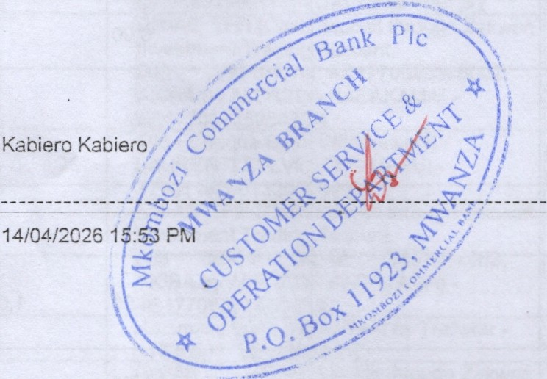-· ----

•

• •

..

•
• • -
• ' - • - •

I

'

•



• •

• •

•

..

•

• •

• ..
f D

....



PAROKIA YA
WA ASIZI- EhF. .£.
. (

f"'1111 ·fI
·'. Ji
K' . \.1\ )" ,
A• '\ Jt
· ';h
1' 1·1 1.f A,
M, 'IJ:"'i..l {VfJ\'.MI ; !'D
).Ji 1.·
J\[ .Ar 1· M:· :A,• ,IH
, ·.I .'T1r·. ),'.\.,J' •1 ,'.

::::;.-'" ') _:,a. ..._,. :;.."" - '1 - =.-. "J - ;,/ - - -

Siku.......................... Tarehe ......................

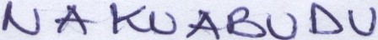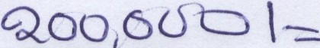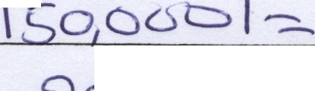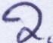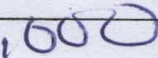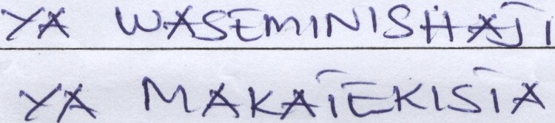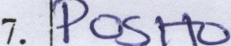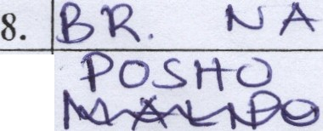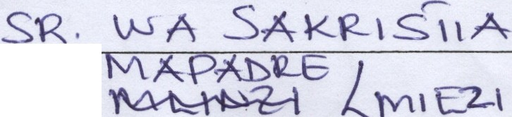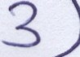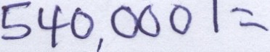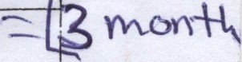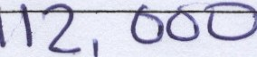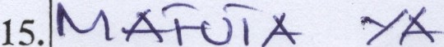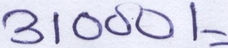•
'

KIASl/TI-IAMANI

-
-
, ' .. """'
-1, . - ,t: A \ . , t

16.

17.

JU1\1LA
IDARA ....l.1.tt-· . .1.
Y,....................................
No.
MA-RIT*JI
lV\
U JV' I 7- I
.
r
•
'o
_· AOD
- 1\..J
.
..
3.
..
\J (\--A'e:> 0 ·, \J 'f
M
--- 4.
5.
tv.. A
...\ PO
YA
<
\J t
ti-D
.....
\ 1'-
u
rv"
. t'A 1s ,,., J'({.:
A \-\- t
A
,
6.
.(.'._ o, C"' I '
-
,
l I
•
3;' f J
•
I
-
'
9.
I' \
\
Goo, ooo
-
-
'
ML\
'i-\
I
.
I
t--
-
t- ---------
YA'- ............A JZ ()k t
--:.-- -
-----
, .lb \'A
e
---+------
kA
Cf ())
I
-f-
C;()O
- -
-
'_1 i ,
•PCL.,3
..(t
13."'1\S
u
A-
Mku £:>
A
us
f
.
• •
.
t
- '
If
•
I .
I





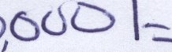

..

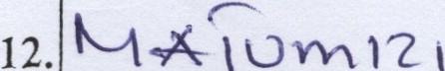

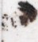

•

TMEIDHINISH\\TA NA :

• 1 . JTNA/SATNT:...............................................................WA DHTFA ................ •

2. JTNA/SAINI.................................................................WADHIFA ...............
•

.., n A nnvn - ···- ······- ··············································

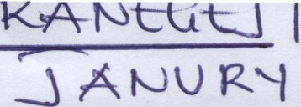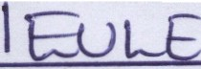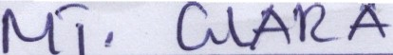t::A-12-o KlA =·
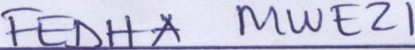\ A-A12-1 \-,A 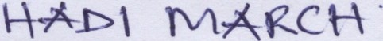
YA
7 •

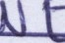

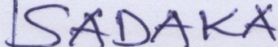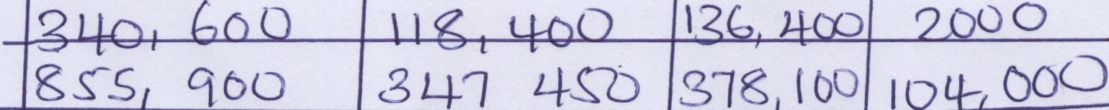, I\\ ovY\ l N l 1<.. A
, .,om1 f'J 1 '.CA YA _i
< '-

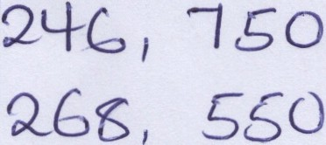13 \ I 0 50

I ,,.£.


:.. -- J 2,ocr Q

,.1'.oM 1N 1 l<- J\- YA J.L
f\,oM 1tJ ' l A YA ( 1 1I
q t; ooo
II5 ;,r . l J.f o1 ()() 0

I r<. UVV'
-
L -A:-

l
•

/

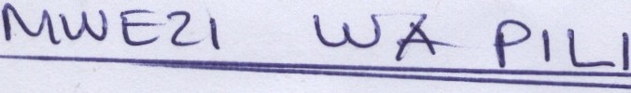\OlY\ lNt k.f\ "IA .. 1-
- ? I l
- t s;()
...._',VY-, 1N \ \<'.'....A_ y ; \ \ -
1 r I 2 CJ ) 1'14-: @Q <60()(Ji. 1

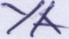<--"
\
YA. . t ,\
.-, J_,,O t;o<J
lq 4-, ' . - , bs,560 4'' I 0

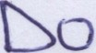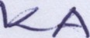

MUj t::0\ LO .. \ - ( L)
' Q_ q ,
300
·
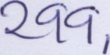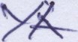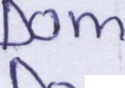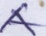)

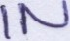
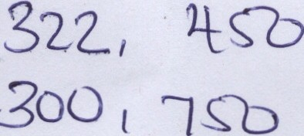l l1<:A YA t l \
OMt \ lc A "l 1-1
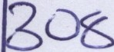_ o t't--J l 1 A YA- ·r '1·

300 1 ·10, \ 00
\'2., ,· O<J 0
L 63,, Soo

\ $(:,,
I, Go o

-
--0 f I 0
5/ 2. , oou

,

6 ·71 <:$J U

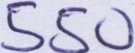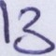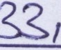

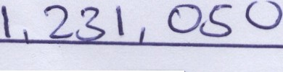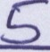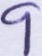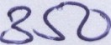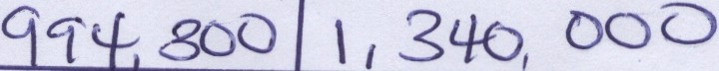

f '
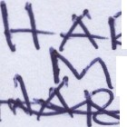-.........,, \ A YA TY\.s:·AV\ A
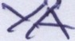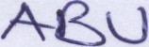......... A-L\ .po 
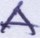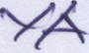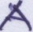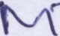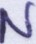  •

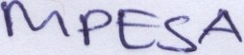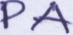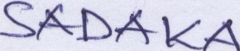I 7-A\< A i "-1\.AS
-DQ&J
1 Lt 1 , lo
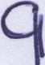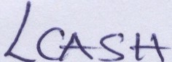8d.3 C t+



t , ' ',,3, 50 0

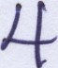l
( I
' I
I I 8, LI- (')
I 7
- .....
I
•
100

